Snehal Raghunath Thomake

Date = 10/11/2022

Batch=7670(Thane)

Defect life cycle

What is a Defect?

A software bug arises when the expected result don't match with the actual results. It can also be error, flaw, failure, or fault in a computer program. Most bugs arise from mistakes and errors made by developers, architects.

Following are the methods for preventing programmers from introducing bugs during development:

* Programming Techniques adopted
* Software Development methodologies
* Peer Review
* Code Analysis

## Common Types of Defects

Following are the common types of defects that occur during development:

* Arithmetic Defects
* Logical Defects
* Syntax Defects
* Multithreading Defects
* Interface Defects
* Performance Defects

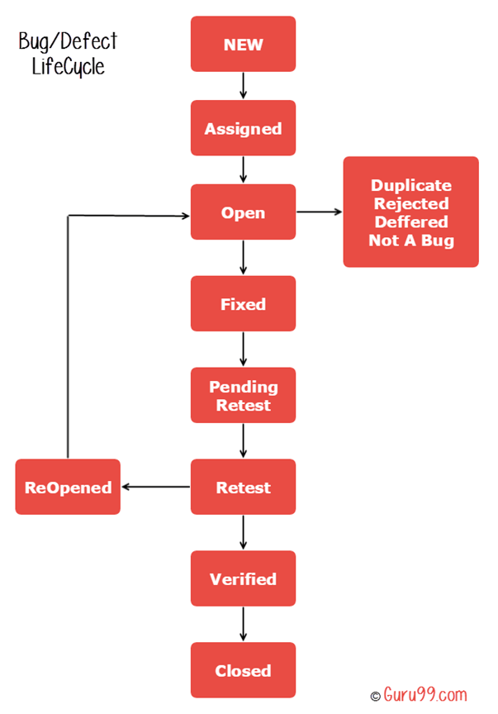

|  |  |  |
| --- | --- | --- |
| **SR.NO** | **Defects** | **Description** |
| 1 | **Arithmetic Defects** | It includes the defects made by the developer in some arithmetic expression or mistake in finding solution of such arithmetic expression. |
| 2 | **Logical Defects** | Logical defects are mistakes done regarding the implementation of the code. When the programmer doesn’t understand the problem clearly or thinks in a wrong way then such types of defects happen. |
| 3 | **Syntax Defects** | Syntax defects means mistake in the writing style of the code. It also focuses on the small mistake made by developer while writing the code |
| 4 | **Multithreading Defects** | Executing or running multiple tasks at the time. Complex debugging is possible in the multiple threading processes. It may also lead to a system crash/failure due to the condition in deadlock |
| 5 | **Minor defects** | Minor defects are usually small, insignificant issues that **don’t affect the function or form of the item**. In most cases, the customer wouldn’t even notice a minor defect on a product |
| 6 | **Major defects** | Major defects are more serious than minor defects. A product with a major defect departs significantly from the buyer’s product specifications.  Major defects are those which could adversely **affect the function, performance or appearance** of a product. |
| 7 | **Critical defects** | Critical defects are the most serious of the three defect types. Critical defects render an item completely unusable and/or could cause harm to the user or someone in the vicinity of the product |
| 8 | ****Design Defects:**** | The algorithms, login and data elements, module interface, the external software and hardware UI descriptions should be correctly designed |
| 9 | ****Command Defects:**** | An error in the sequences and logic is known as control flow error or command error. The reasons for such defects are missing command, wrong algorithm, incorrect data and code errors |
| 10 | ****Boundary Value Defects:**** | In case the login page is logging in by giving the passport length to 16 characters in the place of 15 characters, then the defect is the boundary value defect. |
| 11 | ****Error Handling Defects:**** | The error that is raised while the users interacting with the software need to be handled in the correct flow. The flow should indicate the instruction in the popup message for the mandatory fields to alert the users for incorrect information. |
| 12 | ****Security Defect:**** | The defects will be different by their nature of the risks. These defects are weaknesses allowing for a potential security attack |
| 13 | **Interface Defects:** | The defects in the interactions of the software and the users. Some of the interfaces in the different kinds of forms are complicated interfaces, unclear interfaces and platform based interfaces. |